Project Design Phase
Solution Architecture

Date | 18 JUNE 2026
Team ID
Project Name | Online Complaint Registration System
Maximum Marks | 4 Marks

Solution Architecture:
The Online Complaint Registration & Management System follows a three-tier architecture consisting of a React.js frontend, Node.js/Express.js backend, and MongoDB database. Users can register, log in, submit complaints, track complaint status, and provide feedback. Officers can view assigned complaints and update complaint status, while administrators can approve officers, assign complaints, and monitor system activities. The architecture ensures secure communication through REST APIs and JWT authentication, providing a scalable and reliable complaint management solution.
Example - Solution Architecture Diagram:
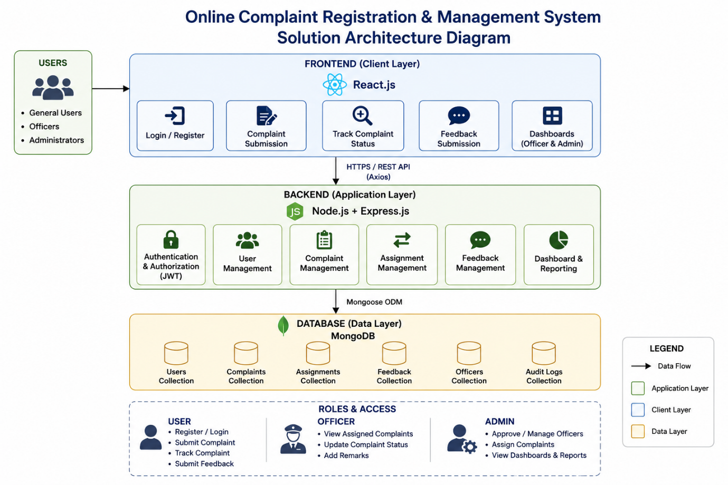

Figure 1: Architecture and data flow of the Online Complaint Registration & Management System
Reference:
https://www.mongodb.com/mern-stack
https://www.mongodb.com/resources/languages/mern-stack-tutorial

